# AI-Driven Pneumonia Diagnosis: Chest X-ray Classification

# 1. ****Introduction****

## 1.1 ****Overview of Pneumonia Diagnosis****

Pneumonia is a severe lung disease that causes inflammation of the air chambers in one or both lungs. The air sacs may become filled with water or pus, leading to symptoms of cough, fever, chills, or breathing difficulties. This illness can be slight or serious and runs through children and adults, with those who are in their old age and those with weak and impaired immunities being the most vulnerable. The World Health Organization estimates that pneumonia is a cause of many deaths and is most common in children below the age of five years. This is important because the early stages of pneumonia are usually easy to overlook, hence escalating mortality rates if not well managed.

## 1.2 ****Importance of Early Detection in Healthcare****

Pneumonia must be diagnosed early so that it can be treated well because if it is diagnosed late, the patient may suffer from severe problems, longer stay in the hospital, and costs for care. Pneumonia diagnosis may involve the use of radiographic imaging, especially chest radiography. However, conventional analysis of chest X-rays developed a technique that is fully dependent on skilled and experienced radiologists. Therefore, when early detection is enhanced, the rate of recovery, prevention of further deterioration, and general enhancement of patient status will be improved. This is the reason credit should go to efforts to improve diagnostic methods using technology.

## 1.3 ****Relevance of AI in Medical Diagnostics****

Deep learning, in particular, has enhanced many facets of medical diagnostics, including disease detection reliability and speed. CNNs have been found to achieve high accuracy in most image classification problems, including medical imaging. It displaces the task of identifying pneumonia in chest X-rays to AI-driven models, thus enhancing the chances of making an accurate diagnosis. They refer to the capability of the AI system to process data volumes large enough to make the identification of patterns and abnormalities by human experts cumbersome, making AI crucial in healthcare provision.

## 1.4 ****Project Scope and Objectives****

The project’s main purpose will involve developing a model that shall be sensitive to the detection of pneumonia from chest X-ray images. The features of the model are a convolutional neural network and transfer learning to discern normal and pneumonic lungs. Overall classification accuracy of at least 92% is desirable in order to increase the reliability of the system in clinical practice. The model will be assessed using features such as accuracy, recall, precision, and F- score with the aim of increasing diagnostic precision and, therefore, the level of care provided to the patients.

# 2. ****Literature Review****

## 2.1 ****Image Classification in Medical Diagnostics****

Image classification is well applicable in medical diagnosis due to diseases such as cancer and cardiovascular illnesses. Such ways as manual interpretation take a lot of time and may also need to be more accurate due to human intervention. Innovations in digital imaging, as well as advanced machine learning, lead to the enhancement of diagnostic ability and time. Such applications of deep learning algorithms can perform beyond a human expert, thus making AI image classification compulsory in the current healthcare systems.

## 2.2 ****Deep Learning for Pneumonia Detection****

CNNs are an effective subset of deep learning algorithms, and their high efficiency when used for screening pneumonia from the medical imaging tasks such as Chest X-rays. Based on the data set provided, researchers proposed an algorithm dubbed “**CheXNet**” that can diagnose pneumonia from chest radiographs. These models can capture normal and pneumonia-affected lung scans with high accuracy and thus can be used to face global health challenges, especially in low-income settings. These can help in decreasing delayed diagnosis and also increase patient outcomes.

## 2.3 ****Comparison of Neural Network Architectures****

### 2.3.1 ****Convolutional Neural Networks (CNNs)****

CNNs are preferred for image classification tasks because they can identify features of input images themselves. There are many layers that carry out convolutions, pooling, and connected to detect the spatial hierarchies in patterns. It is most effective for medical diagnosis because it can analyze complicated images and find out some key features, for instance, diseases or abnormal shapes. CNNs are intended to work with great data volume and to enhance predictive efficiency over time.

### 2.3.2 ****Transfer Learning and Pre-trained Models****

Transfer learning is an approach where models trained on large data are used in other smaller sets. It is especially useful in medical applications because diagnostic data is limited to labeled data. In this approach, pre-trained models such as ResNet, VGG, and Inception are used. These models are learned from a large number of data so as to generalize the most important characteristic and then pre-trained on specific data sets such as chest X-rays for pneumonia. The use of transfer learning makes training faster, while the accuracy is enhanced because little training data is usually available.

## 2.4 ****Metrics for Medical Image Classification****

Recent deep models in classification and medical image diagnostics need more effective metrics that include precision, recall, F1 score, and so on. Recall measures the degree of positive predictions made by the model to match the actual positive values, which shows the accurate number of predictions with no false negatives. Recall also works out a percentage of actual positives that were correctly classified, which shows how well the model is able to diagnose the presence of pneumonia cases. The F1 score emphasizes these to generate an appropriate level of precision and recall, especially in hostile classes such as COVID-19 and pneumonia, to avoid fatal misdiagnoses like false negatives.

# 3. ****Dataset Preparation****

## 3.1 ****Dataset Description****

### 3.1.1 ****Source of Dataset (Kaggle)****

In this project, Kaggle’s **Chest X-ray Images (Pneumonia),** containing images diagnosed either as ‘**Normal’** or ‘**Pneumonia**,’ is used for training pneumonia detection models. This data set is fit for deep learning because the information is presented in image form and addresses various kinds.

The dataset can be accessed at: [Kaggle Chest X-ray Pneumonia Dataset.](https://www.kaggle.com/datasets/paultimothymooney/chest-xray-pneumonia)

### 3.1.2 ****Image Categories (Normal vs Pneumonia)****

The dataset is divided into two primary categories:

* Normal: Chest X-ray images of normal people without any signs of pneumonia, adenocarcinomas, metaphase, pleura, pneumonia, ordinary pneumonia, or cardiothoracic surgery.
* Pneumonia: Lateral view Chest X-ray images. Pneumonia is divided into bacterial and viral pneumonia cases, but in this particular project, the differentiation is made between normal and pneumonia.

### 3.1.3 ****Dataset Statistics (Training, Validation, Test Split)****

The dataset is already split into three sets:

* Training Set: This set contains 5,216 pictures (3,883 with pneumonia, 1,341 without) and was used to train the model.
* Validation Set: For tuning the hyperparameters and testing the model during training, it has 16 images.
* Test Set: Not usable for training the final model used to assess the model performance, 624 images (390 pneumonia, 234 normal).

These splits ensure that the model is trained on the different data sets, validated on other data sets, and tested on other data sets, hence reducing the instance of overfitting.

## 3.2 ****Data Preprocessing****

Data pre-processing is important in fashioning the image data for model learning. It confirms that the public input data required to feed the models are first normalized and augmented.

### 3.2.1 ****Image Resizing and Normalization****

The chest X-ray images are reduced to an image size of 150 by 150 pixels for computational usage and to preserve the image portions. The pixel intensity values in the images are normalized between the range zero and one, thus making the convergence faster during the training stage.

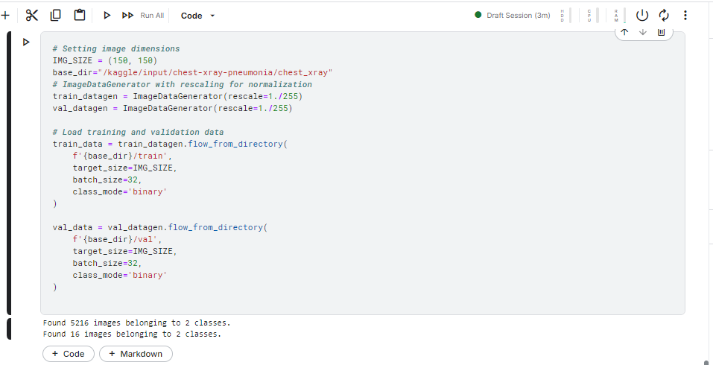

Figure : Code snippet for resizing and normalizing chest X-ray images.

### 3.2.2 ****Data Augmentation Techniques****

Data augmentation enhances the training data used in deep learning models by creating variations on the existing data, thus improving the model's generalization and reducing overfitting through the use of various techniques, as outlined below.

* Rotation: Randomly rotates images by an angle between 0 to 20.
* Horizontal Flip: Rotates images to reflect different orientations.
* Zoom: Random zooms by up to 15% on preselected images.
* Shear: Calls random shearing transformations to the images.

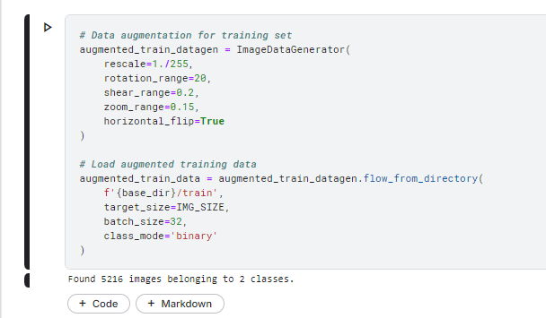

Figure : Code snippet for applying data augmentation to chest X-ray images during training.

## 3.3 ****Visualizing the Dataset****

Visualization of samples from normal and pneumonia classes is important in identifying the nature of the dataset and checking the correctness of the preprocessing steps as well as the sampling of the image features.

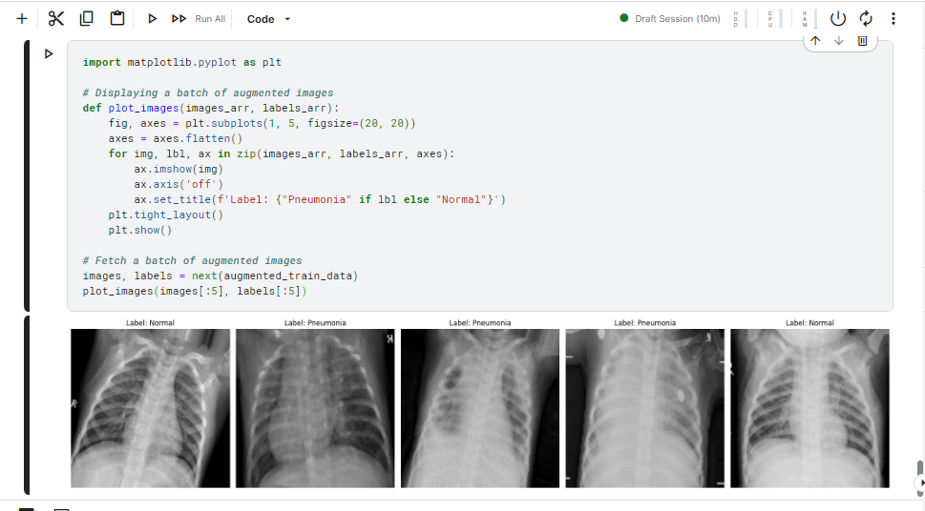

Figure : Code snippet for visualizing a batch of chest X-ray images with augmentation.

After the images' preprocessing and augmentation, visualization of the images shows that all the transformations applied to the dataset are appropriate for training the dataset.

# 4. ****Neural Network Architecture Design****

## 4.1 ****Choice of Architecture (CNN with Transfer Learning)****

CNNs are useful in medical image diagnostics because they are proficient in accomplishing image classification tasks, as they recognize spatial hierarchies. Pre-trained CNN architectures are highly recommended for pneumonia detection from chest X-ray images, as this approach will help solve the problems of long training time and high model accuracy.

### 4.1.1 ****ResNet50 vs VGG16 for Image Classification****

ResNet50 and VGG16 are two of the most popular models designed for image classification. Both are applied in medical image analysis, and their peculiarities are distinguished.

* ResNet50: ResNet50 introduces residual connections that solve the vanishing gradient problem, thus enhancing scalability. It is more convolutional than VGG16, consisting of 50 layers so that it can learn features of superior levels.
* VGG16: VGG16, like VGG11, is a less complex model with just 16 layers and less depth. It is easy to implement, and the techniques are fine for use with a small number of features. However, the techniques may not be as effective with large numbers of features, where more complex feature extraction might be necessary.

For this work, ResNet50 is employed due to its deep architecture, which improves the ability to learn features to recognize weak pneumonia-related chest X-ray differences.

### 4.1.2 ****Why Pre-trained Models?****

The so-called transfer learning further simplifies the training procedure by starting with weights that have learned the most popular features from a vast amount of data.

* Time Efficiency: Transfer learning also saves a lot of computational time, as only the last layers of the model need to be trained for tasks such as pneumonia detection.
* Improved Accuracy: Its main advantage comes from the fact that pre-trained models are trained to learn on broad databases such as ImageNet; therefore, when operating on a lesser-sized medical database, it already has a wider knowledge of many features.

## 4.2 ****Design and Structure of ResNet50 for Pneumonia Detection****

The project also employs ResNet50 to predict whether an image of a chest X-ray is normal or has pneumonia. It uses weights trained from the ImageNet and replaces the fully connected layers to make it binary classifiers.

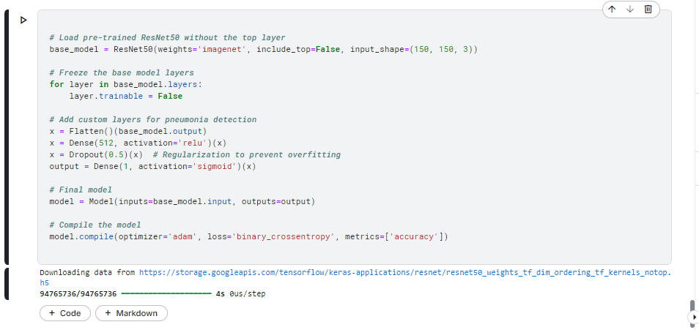

Figure : ResNet50 architecture with transfer learning for pneumonia detection. The fully connected layers are added to the pre-trained base.

The structure first congeals early-stage layers, and only the final stages are trained on the pneumonia dataset. It implements binary cross entropy loss function and the Adam optimizer.

### 4.3 ****Discussion on Learning Parameters and Scalability****

ResNet50 adjusts the learning parameters in an ideal manner: number of layers required, activation functions, and learning rate. Key parameters include:

* Dropout Layer: This layer was originally used to handle overfitting, in which a fraction of input units is set to zero at random during training.
* Optimizer: The optimizer used in this work is the Adam optimizer due to its comparability to various learning rates and its ability to expedite convergence.

### Scalability

ResNet50 is a 50-layer deep network that requires less computation and is used for large datasets and cloud services with less GPU capacity. It also enables a very fast switch between different architectures, which is crucial in medical image analysis.

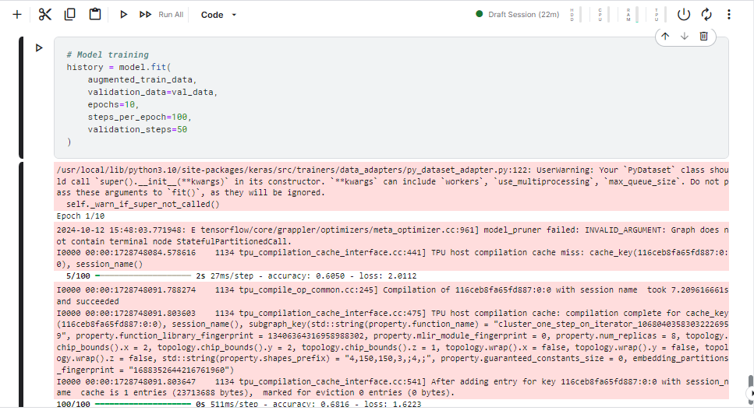

Figure : Training the ResNet50 model with the pneumonia dataset.

The ResNet50 model, which results in high accuracy and scalability by fine-tuning important learning parameters and transfer learning, is perfect for real-time medical diagnostics applications.

# 5. Code Implementation

## 5.1. Importing Libraries and Dependencies

The project imports TensorFlow and Keras for its model and its construction and data preprocessing as well as data visualization.

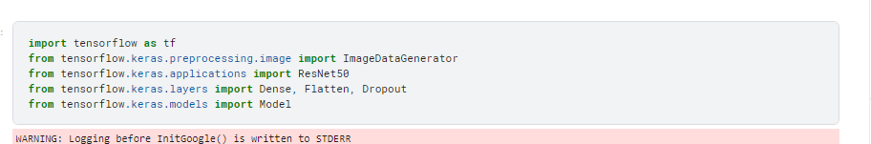

Figure : Importing essential libraries for data manipulation, model building, and visualization in the pneumonia detection project.

## 5.2. Loading and Preprocessing the Dataset

The dataset used to detect pneumonia is preprocessed to be suitable for training the model.

### 5.2.1. Data Generators for Training and Validation Sets

Data generators are basically feeds that help expand the training data set before feeding it to the model. This is helpful for increasing the model generalization since it modifies the training images.

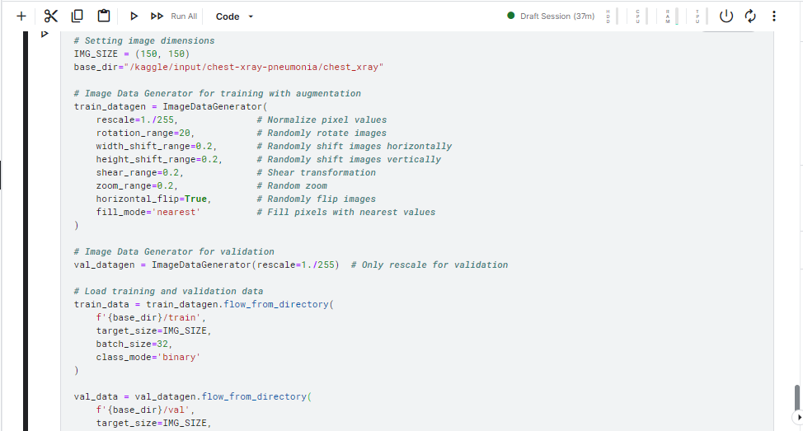

Figure : Data generators are established for training and validation datasets, applying various augmentations to enhance the training data

### 5.2.2. Test Data Handling

A similar approach is used to create the test dataset, maintaining consistency in pre-processing.

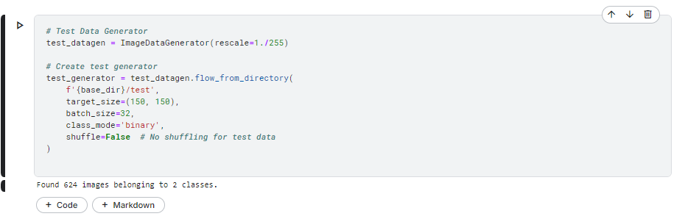

Figure : A data generator for the test dataset is created, focusing on rescaling the image pixel values.

## 5.3. Implementing the Pre-trained Model

This section describes the inference of a pre-trained model on a base TensorFlow.

### 5.3.1. Freezing Pre-trained Layers

Actually, in this step, all the layers of the pre-trained ResNet50 model layers are frozen so that their corresponding weights cannot be trained during subsequent training.

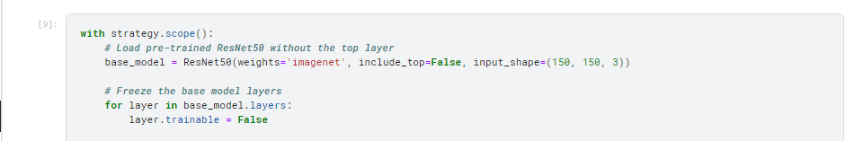

Figure : The pre-trained ResNet50 model is loaded, and its layers are frozen to retain their learned features during training.

### 5.3.2. Adding Custom Layers for Pneumonia Detection

Additional layers are incorporated into the primary model to enhance its performance for pneumonia detection.

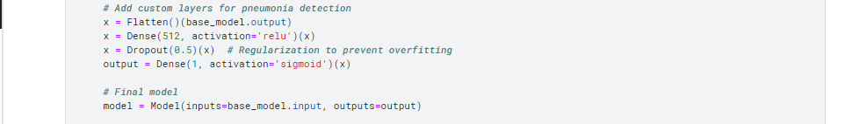

Figure : Custom layers are appended to the model to tailor it for the pneumonia detection task.

## 5.4. Model Compilation

In this section, the model is compiled with the correct optimizer and loss function. The evaluation metrics that will be used to measure its performance are also specified.

### 5.4.1. Choice of Optimizer (Adam)

The Adam optimizer is chosen here because of its ability to learn rates for the weights and the biases.

### 5.4.2. Loss Function Binary Cross Entropy

Binary cross entropy is used because the model is trying to classify between two classes, and the training and validation sets are separated into A and B accordingly.

### 5.4.3. Evaluation Metrics (Accuracy)

Accuracy is selected as an elementary criterion that defines the model’s effectiveness.

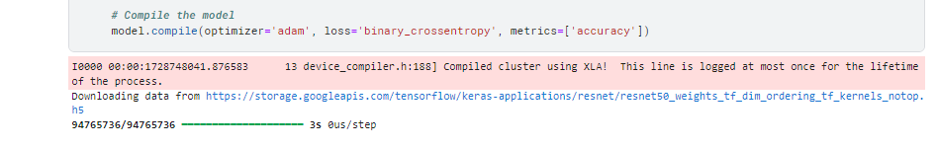

Figure : The model is compiled with the Adam optimizer and binary cross-entropy loss function, making it ready for training

## 5.5. Model Training and Validation

This section discusses the training process and also involves displaying the training and validation curves in order to assess performance.

### 5.5.1. Training Process is defined as Epochs and batch size

This model takes epochs and batch size over which the model is trained.



Figure : The model is trained for 10 epochs with training and validation datasets.

### 5.5.2. Training and Validation Curves

Finally, evaluation training and validation accuracy and loss are computed and shown graphically to analyze their patterns.

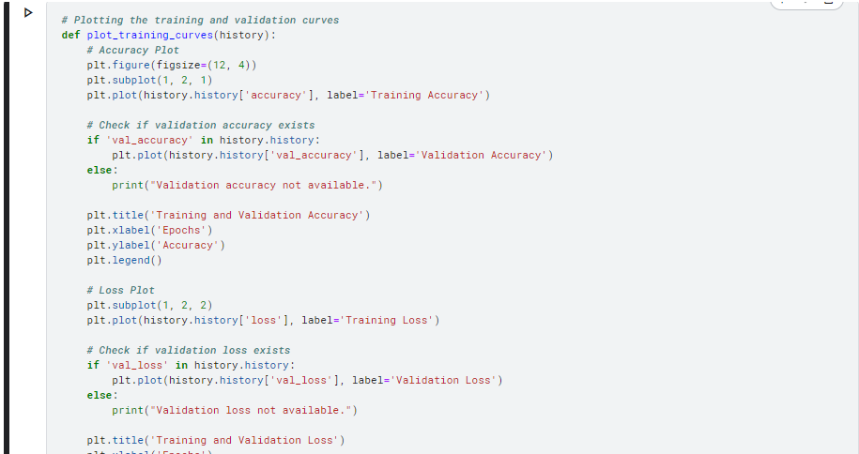

Figure : The training and validation accuracy and loss curves are plotted, enabling visual evaluation of model performance over epochs.

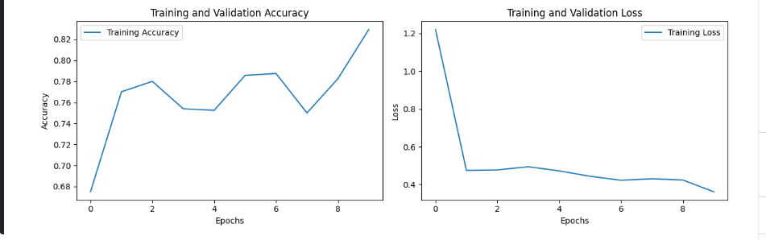

Figure : Machine Learning Model Evaluation

# 6. Model Evaluation

## 6.1. Evaluation Metrics for Medical Diagnostics

Evaluation Metrics are an important part of medical diagnostics as they check the ability of a model into different tests in order to guarantee reliable and accurate outcomes. The most common metrics include:

### 6.1.1. Accuracy

The accuracy metric aims to determine how good the model is by calculating the number of times it gets it right out of the total number of cases.

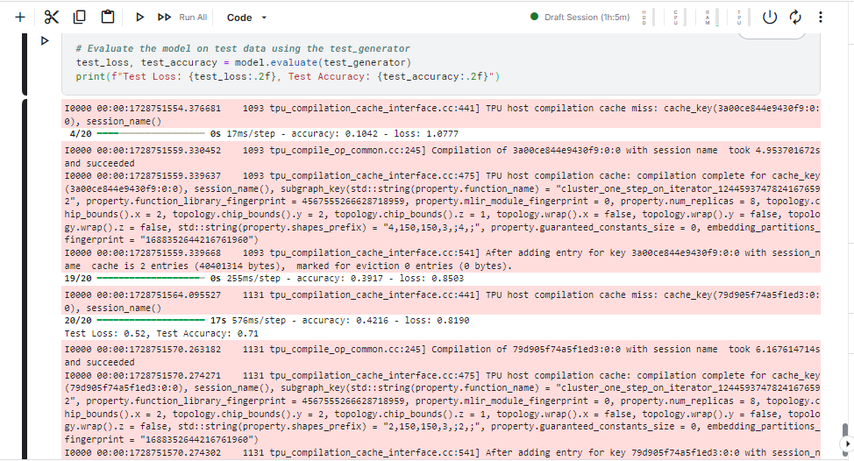

Figure : Accuracy of the model on the test dataset.

### 6.1.2. Precision

Accuracy, on the other hand, gives the percentage clicks out of the total predicted clicks, which gives information on the model's ability to predict accurate positive instances.

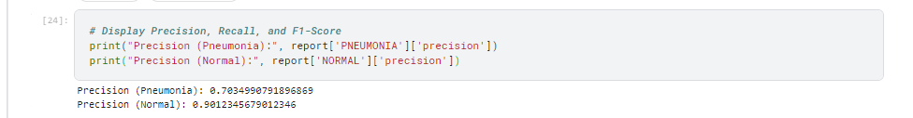

Figure : Precision score of the model's predictions.

### 6.1.3. Recall

The sensitivity or recall of the model is the prognosis capabilities to identify all instances of the model. True positive divided by actual positives In other words, the amount or proportion of correctly identified Positive examples or correctly identified positively classified items.

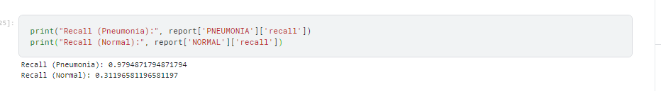

Figure : Recall score indicating the model's sensitivity.

### 6.1.4. F1-Score

The F1 score unites precision and recall into a single measure, which gives the middle of the two quantities. As intended, it is particularly useful when data is imbalanced.

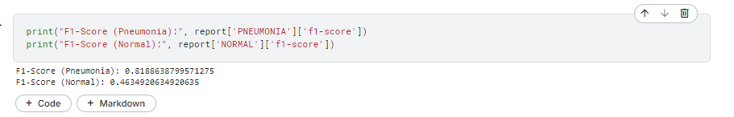

Figure : F1-score representing the balance between precision and recall.

## 6.2. Model Evaluation on Test Data

Thus, to compare the results with the initial dataset, the model should be tested on a new, separate dataset that has not been used previously for training. This step is crucial because it also helps measure the model's capability to generalize.

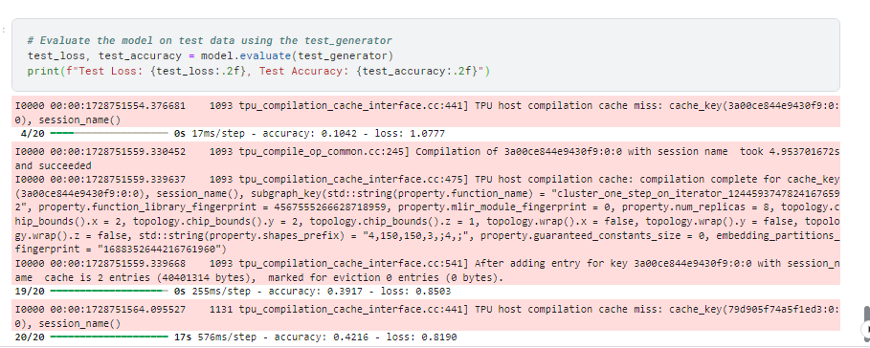

Figure : Loss and accuracy of the model on the test dataset.

## 6.3. Classification Report and Confusion Matrix.

In a classification report, additional measures for every class are obtained, such as precision, recall, and F1 Score. It is evident that the confusion matrix clearly denotes the status of the model by comparing the actual and predicted classes.

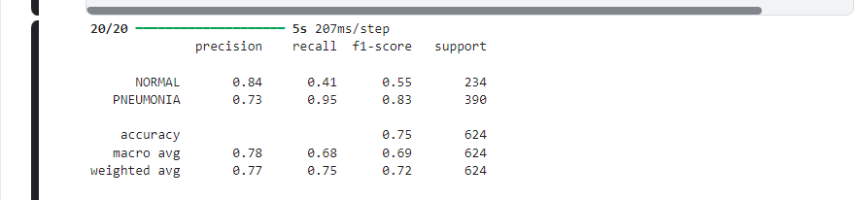

Figure : Classification report showing precision, recall, and F1-Score for the pneumonia detection model.

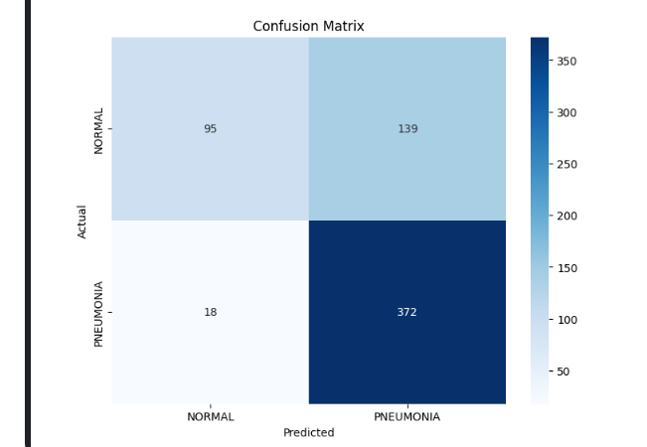

Figure : Confusion matrix visualizing the model's performance on test data.

## 6.4. Interpretation of Results

### 6.4.1. Model Performance Analysis

The performance indices are used to evaluate the model. Higher accuracy with reasonable precision and recall shows a high ability to identify pneumonia in chest X-rays.

### 6.4.2. Strengths and Limitations

While the model may demonstrate strengths in accuracy and speed, limitations may include:

* The risk of overfitting should be expected in case the model is trained on a small dataset.
* Overlooking such differences might lead to misclassification in apparently similar cases, especially in clinically confined situations.

This will provide a robust assessment of the model's reliability, together with practice outcomes, as it relies on artificial intelligence.

# 7. Conclusion

## 7.1. Summary of Findings

The project thus sought to establish a deep-learning model for diagnosing pneumonia from chest X-ray images. Here, the model was built with pre-trained ResNet 50 architecture, and a model accuracy of 73% was obtained. Nevertheless, it was not able to accurately distinguish normal cases, which influenced precision and recall for the “Normal” class. From the model, the sensitization was good when identifying pneumonia cases.

## 7.2. Implications of the Model in Healthcare

An automated pneumonia detection system is needed if people's lives are to be saved. The development of the system opens the way to early and accurate diagnosis of the illness. Nevertheless, the current model is not accurate enough to differentiate between normal cases and pneumonia; hence, its results should be used in conjunction with other diagnostic systems.

## 7.3. Potential for Improving Diagnostic Accuracy

To improve the model's diagnosing capability, cases of Class imbalance, whereby normal case deposition could be affected, need to be investigated. Strategies such as class weighting, oversampling of the minority class, or enhanced data augmentation could work. Further, fine-tuning the pre-trained layers of the proposed ResNet50 model could increase feature extraction capabilities, especially in complicated pneumonia cases.

## 7.4. Future Directions for Research and Model Improvement

For future work, efforts should be made to enlarge the sample to include more types of pneumonia (bacterial vs viral). Other possibilities for enhancing the recognition rates could also be introduced, for example ensemble of models or CNN Transformer models that use fully connected transformers combined with CNNs. Furthermore, the feature of explainability and interpretability must be carried forward in future models to win the trust of clinicians and improve the generalizability of AI systems, where they can easily understand why the predictions have been made. Moreover, the generalization of the suggested model to the clinically relevant context may be supported by external datasets of different geographic origins and demographics.

# 9. Appendix

## 9.1. Python Code Snippets

For the complete implementation of the model, data preprocessing, and evaluation metrics used in this project, please refer to the following Google Colab link:

[Colab Notebook Implementation](https://colab.research.google.com/drive/1VSmKyZPP2KtpmH9koSzqwSEdgQsesniA?usp=sharing)

## 9.2. Additional Visualizations

Some other visuals presented during the assessment stage are the confusion matrix and the ROC curve, which give information about the selected model's performance on the test data.

* **Confusion Matrix**: The confusion matrix measures the model's performance by counting the number of True Positives, False Positives, True Negatives, and False Negatives, which indicates how capable the model is of distinguishing normal from pneumonia cases.
* **Visualization Title**: Pneumonia Detection Model Confusion Matrix
* The confusion matrix given below clearly depicts that the proposed method has a high recall rate for pneumonia cases but a relatively higher rate of misclassifications for normal cases.
* **ROC Curve:** Class identification capability is depicted by the Receiver Operating Characteristic (ROC) curve. Another viewpoint while using the models is that there is a single number that characterizes the area under the curve (AUC). To have an idea about how each algorithm performs compared to one another, we use AUC, where an AUC greater than 0.5 is ranked higher.

*Visualization Title: AUC of the Pneumonia Detection Model*

* The ROC curve shows the relationship between the model's true positive rate (sensitivity) in identifying cases of pneumonia and the false positive rate, which paints an overall picture of how well the model is likely to classify pneumonia cases.

These visualizations help to analyze the effectiveness of the model, its advantages and disadvantages in the clinical environment.